**Human Biology – General Year 12 2019**

## Unit 3 – Task 6 – Endocrine Disorders

**Assessment Type:** Extended Response

**Task Weighting :** 10% **Due Date : _____________________________**

**Name : ________________________________________________________________________________**

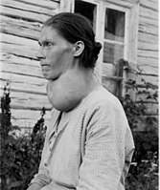

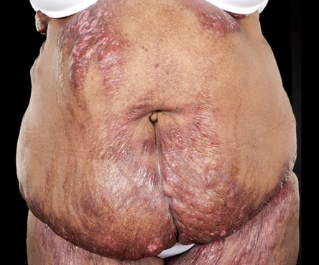

The endocrine system plays a vital role in maintaining your body within **tolerance limits**, and when part of it stops functioning properly, it can have damaging effects on your health and development.

In 2012, endocrine and metabolic diseases accounted for 4.1% of all registered deaths in Australia (ABS), and the number of people dying from these disorders has increased from 4,721 people in 2003 to 6,047 in 2012!

It is very likely that you will know someone with an endocrine dysfunction over your lifetime; therefore, you must develop an understanding of the common endocrine dysfunctions so that you can reduce your risk of developing one, or identify the symptoms in a friend or family member to ensure they visit a doctor.

The following assessment is presented in three parts.

**Part One 30%**

You must construct research notes on several hormones, and dysfunctions associated with thyroxine, cortisol and growth hormone.

**Part Two 20%**

You must create a poster about one of the disorders researched above. The poster will be used to teach the EGC students of 2020.

**Part Three 50%**

You will sit an in-class authentication of your understanding of endocrine dysfunction. This will be a test.

|  |  |  |  |
| --- | --- | --- | --- |
| **Part One** | **Part Two** | **Part Three** | **TOTAL** |
| /36 | /16 | /25 | **%** |
| *0.3 = | *0.2 = | *0.5 = |

Name:________________________________________________

**Part One: Research Notes**

You must **individually** research and construct notes on the following hormones and their feedback loops in the human body for metabolism.

|  |  |  |  |  |  |  |
| --- | --- | --- | --- | --- | --- | --- |
| **Hormone** | **Stimulus** | **Receptor** | **Modulator** | **Effector** | **Response** | **Feedback** |
| **Thyroxine** |  |  |  |  |  |  |
| **Cortisol** |  |  |  |  |  |  |
| **Growth Hormone** |  |  |  |  |  |  |
| **Adrenaline** |  |  |  |  |  |  |

**/12**

|  |  |  |  |  |  |
| --- | --- | --- | --- | --- | --- |
| **Hormone** | **Dysfunction** | **Cause** | **Symptoms** | **Treatment** | |
| **Non-hormonal treatment** | **Hormone Replacement Therapy** |
| **Thyroxine** | **Hypothyroidism** |  |  |  |  |
| **Hyperthyroidism** |  |  |  |  |
| **Cortisol** | **Cushing’s Disease** |  |  |  |  |
| **Addison’s Disease** |  |  |  |  |
| **Growth Hormone** | **Growth Hormone Deficiency** |  |  |  |  |
| **Acromegaly** |  |  |  |  |

**/24**

Name:________________________________________________

**Part Two: Poster**

You must create an engaging poster to teach other EGC students about one of the disorders you have researched. Your poster can be either **digital** or **hardcopy**. Whichever way you choose, your poster must be able to be printed and/or laminated for future students to read from.

Your poster must address the statement – ***“Why you need to know about [chosen dysfunction]’.***

The purpose of your poster is to make other students understand that it is important for them to learn about your chosen disorder, and as such, you will need to present information on:

* How the hormone that causes your dysfunction is normally regulated
* What homeostasis is and how your disorder disrupts homeostasis
* The causes, symptoms and treatment options for your disorder
* An evaluation of whether you believe that Australians should be more worried about your chosen disorder than diabetes, another common endocrine dysfunction. To do this you will need to research statistics and information about the severity and prevalence of each dysfunction in Australia and present a brief argument.

Your poster will be graded against the rubric below.  **/16**

|  |  |  |  |  |  |  |  |  |
| --- | --- | --- | --- | --- | --- | --- | --- | --- |
| **Question** | **A** | | **B** | | **C** | | **D** | |
| **4** | **3.5** | **3** | **2.5** | **2** | **1.5** | **1** | **0.5** |
| How the hormone that causes your dysfunction is normally regulated | Uses appropriate scientific language, conventions and clearly labelled diagrams to correctly explain concepts. | | Uses scientific language, conventions and labelled diagrams to explain concepts. | | Uses some scientific language, conventions and supporting diagrams to describe concepts. | | Uses everyday language and provides simple diagrams to describe some concepts. | |
|  | **4** | **3.5** | **3** | **2.5** | **2** | **1.5** | **1** | **0.5** |
| What homeostasis is and how your disorder disrupts homeostasis | Applies concepts and scientific knowledge to describe structures and systems and explain processes, in detail. | | Applies concepts and scientific knowledge to describe structures and systems and explain some processes. | | Describes some structures, systems and processes in a general way. | | Identifies some structures, systems and processes. | |
|  | **4** | **3.5** | **3** | **2.5** | **2** | **1.5** | **1** | **0.5** |
| The causes, symptoms and treatment options for your disorder | Communicates information and concepts logically, using correct scientific language, conventions and representations. | | Communicates information and concepts generally using scientific language and representations. Makes some errors in the use of conventions. | | Communicates information and concepts, without detail, using some scientific language and conventions. | | Communicates information using everyday language with frequent errors in the use of conventions. | |
|  | **4** | **3.5** | **3** | **2.5** | **2** | **1.5** | **1** | **0.5** |
| An evaluation of whether you believe that Australians should be more worried about your chosen disorder than diabetes | Analyses issues and presents clear and logical arguments or reasons which are supported by evidence.  Selects and assesses the relevance of scientific information from a variety of sources to support a point of view. | | Analyses issues and presents arguments or statements that are sometimes well supported by evidence.  Selects scientific information from a variety of sources to support a point of view. | | Discusses issues and presents general statements supported by limited evidence.  Selects limited scientific information to support a point of view. | | Discusses issues and presents general statements that may include incomplete or incorrect information.  Makes little use of evidence to support a point of view. | |

Name:________________________________________________ **/25**

**Part Three: Endocrine Dysfunction Test**

1. With the aid of a diagram, describe how a negative feedback loop works to maintain your body within tolerance limits.

(6 marks)

__________________________________________________________________________________________________________________________________________________________________________________________________________________________________________________________________________________________________________________________________________________________________________________________________________________________________________________________________________________________________________________________________________________________________________________________________________________________________________________________________________________________________________________________________________________________________________________________________________________________________________________________________________________________________________________________________________________________________________________________________________________________________________________________________________________________________________________________________________________________________________________________________________________________________________________________________________________________________________________________________________________________________________________________________________________________________________________

1. Your Aunt Mildred has been taking medication for Hypothyroidism.
2. State which hormone is not being kept in balance. (1 mark)

__________________________________________________________________________________________

1. State four symptoms of the condition.

(2 marks)

______________________________________________________________________________________________________________________________________________________________________________________________________________________________________________________________________________

1. Explain how the hormone is regulated when its levels become too high. (4 marks)

________________________________________________________________________________________________________________________________________________________________________________________________________________________________________________________________________________________________________________________________________________________________________________________________________________________________________________________________________________________________________________________________________________________________________________________________________________________________________________________________________________________________________________________________________________________________________________________________________________________________________________________________________________________________________________________________________________________________________________________________________________________________________________________________________________________________________________________

1. Describe why this is considered a negative feedback loop

(1 mark)

____________________________________________________________________________________________________________________________________________________________________________________

1. Describe how hormone replacement therapy/medications can be used to treat the condition.

(3 marks)

____________________________________________________________________________________________________________________________________________________________________________________________________________________________________________________________________________________________________________________________________________________________________________________________________________________________________________________________________________________________________________________________________________________________

1. Explain how cortisol increases metabolism.

(3 marks)

____________________________________________________________________________________________________________________________________________________________________________________________________________________________________________________________________________________________________________________________________________________________________________________________________________________________________________________________________________________________________________

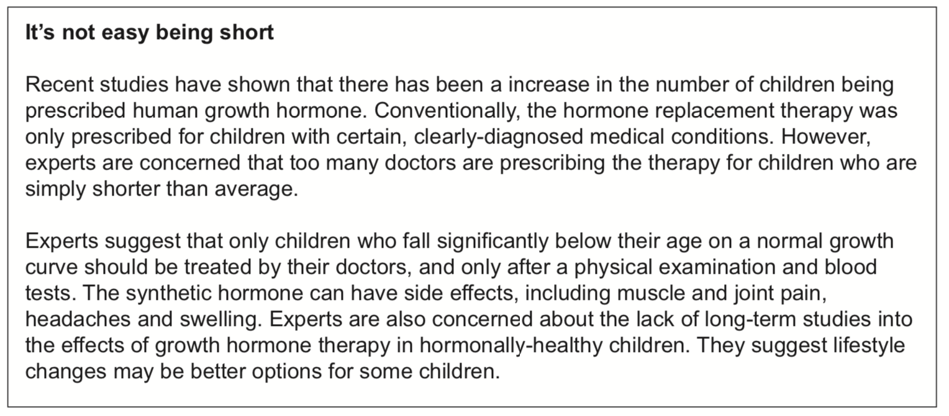Hormone replacement therapies can be used to treat a range of endocrine disorders. The following questions relate to the article about growth hormone replacement therapy below.

1. What is a *synthetic* hormone and why might it be needed?

(2 marks)

________________________________________________________________________________________________________________________________________________________________________________________________________________________________________________________________________________________________________________________________________

1. Observe the advertisement below, which claims to help you to grow taller, later in your life.
2. Using your understanding of the endocrine system, explain why this advertisement is misleading. (3 marks)

________________________________________________________________________________________________________________________________________________________________________________________________________________________________________________________________________________________________________________________________________________________________________________________________________________________________________________________________________________________________________________________________________________________________________________________________________________________________________________________________________________________________________________________________________________

